**Assignment 1: Scene and UI 28.03.2025**

**Aldongar Yerkin SE 2318**

1. Setting up the environment

I added a Terrain object to the scene, and placed three unique objects on it:

• a tree (trunk — cylinder, crown — sphere),

• house (cube),

• a tower (a tall cylinder).

Also I adjusted the lighting and camera position so that the scene looked balanced visually.

Terrain

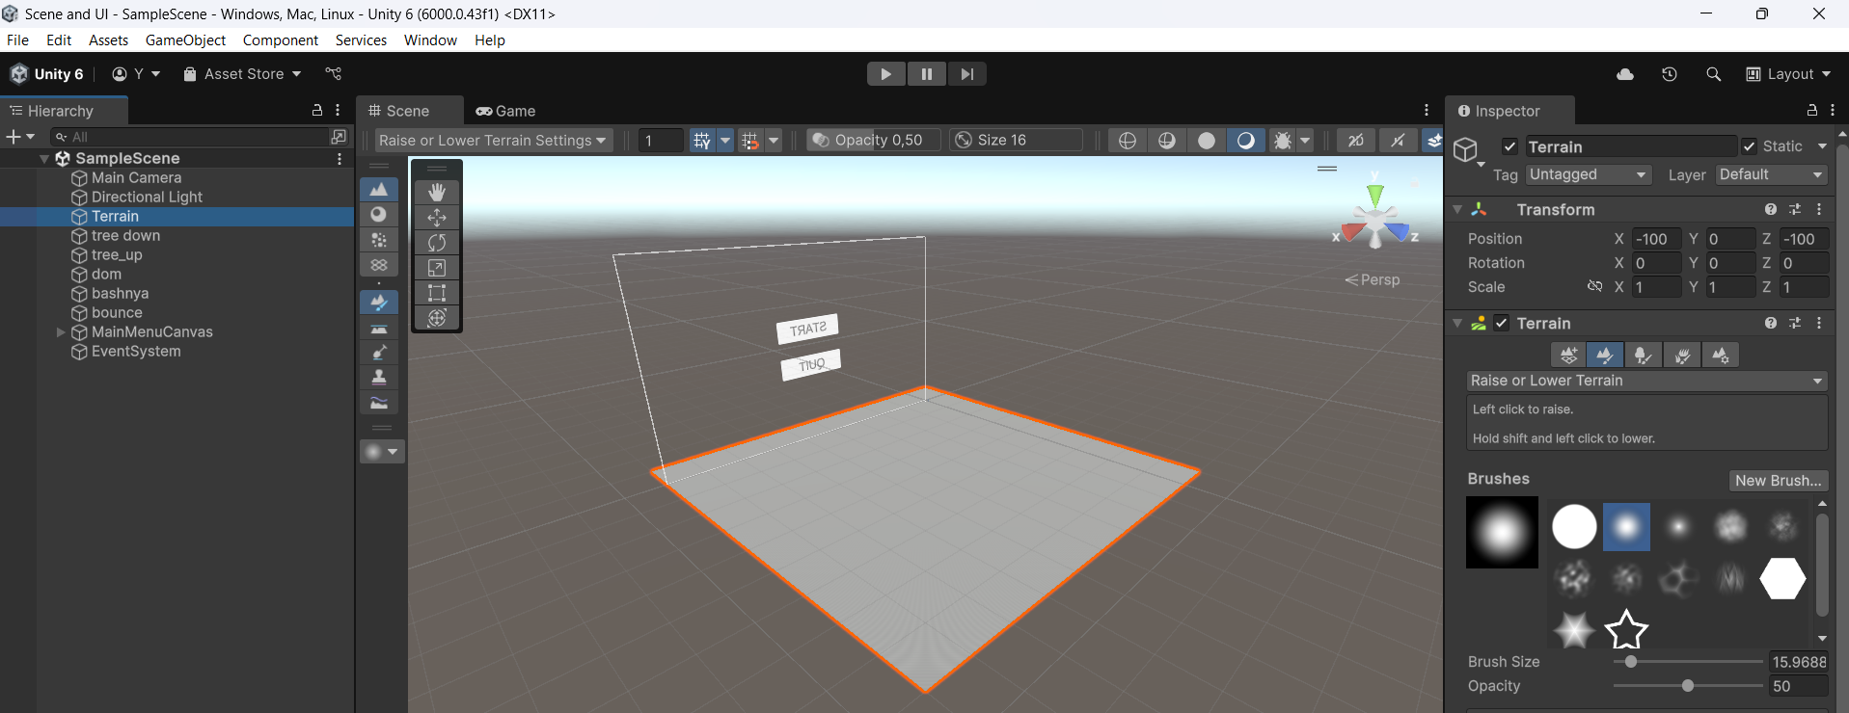

Tree (trunk)

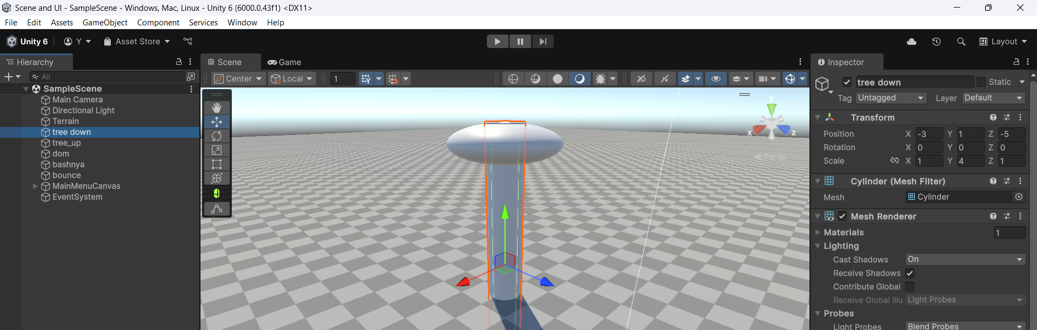

Tree (crown)

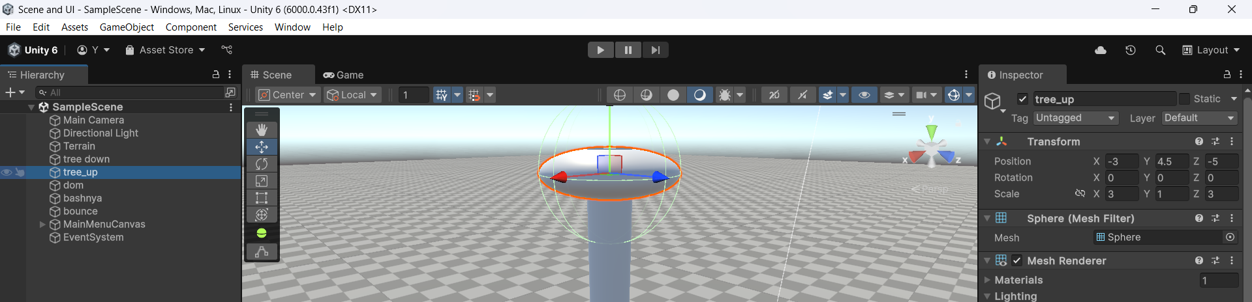

House

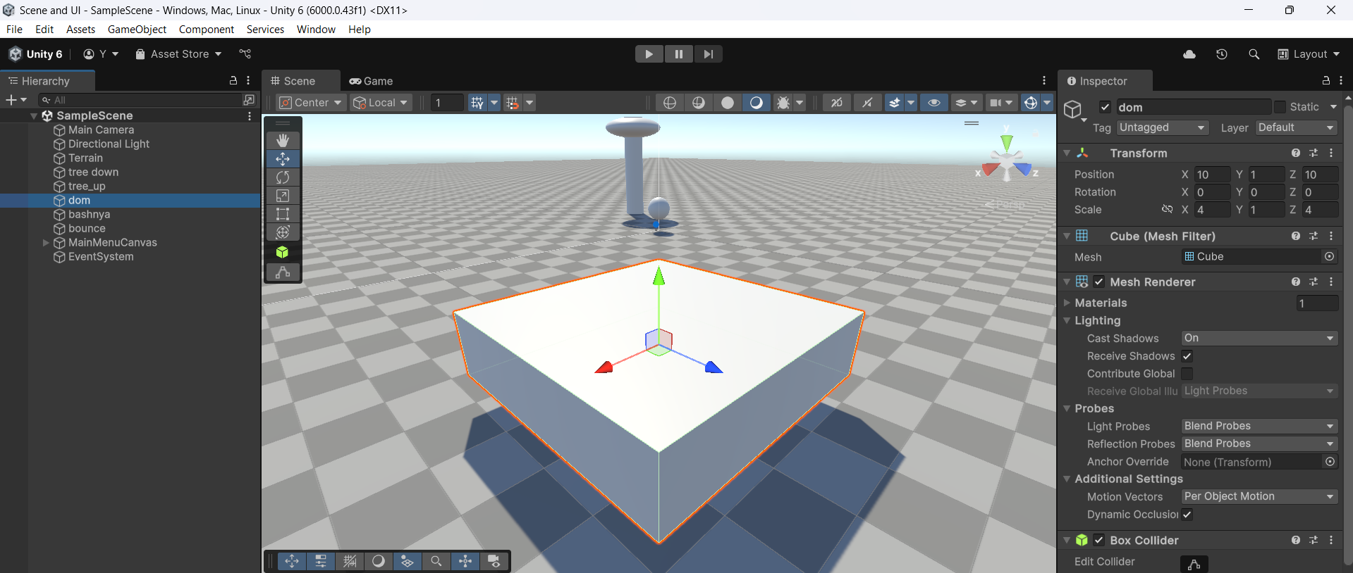

Tower

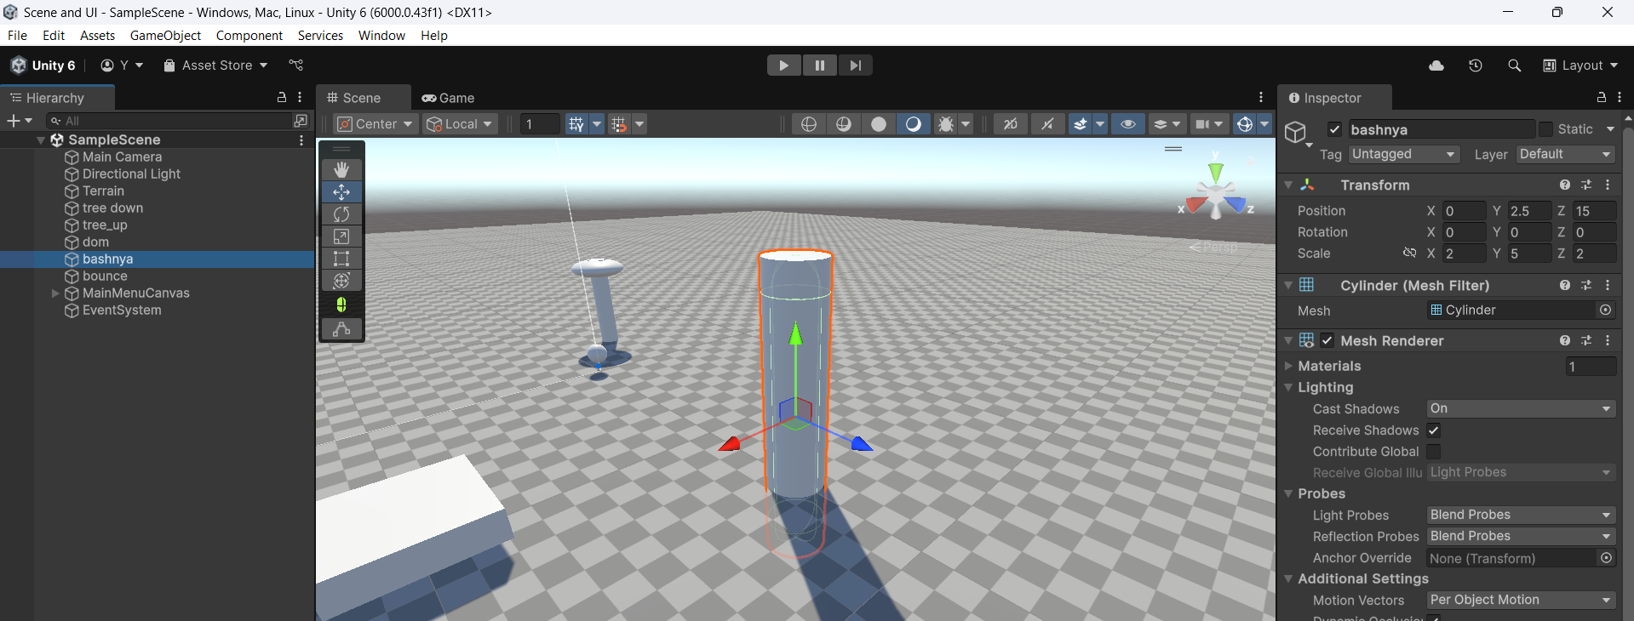

2. Animation

Added the bounce ball object. Created a jump animation using the Animation window:

• on frame 0: position Y = 1,

• on frame 30: Y = 3,

• at frame 60: Y = 1 again.

The animation is looped through Loop Time. Thus, the ball bounces endlessly.

Position 1 (frame 0)

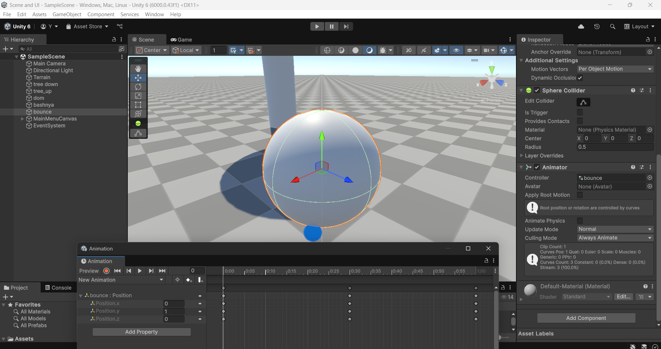

Position 2 (frame 30)

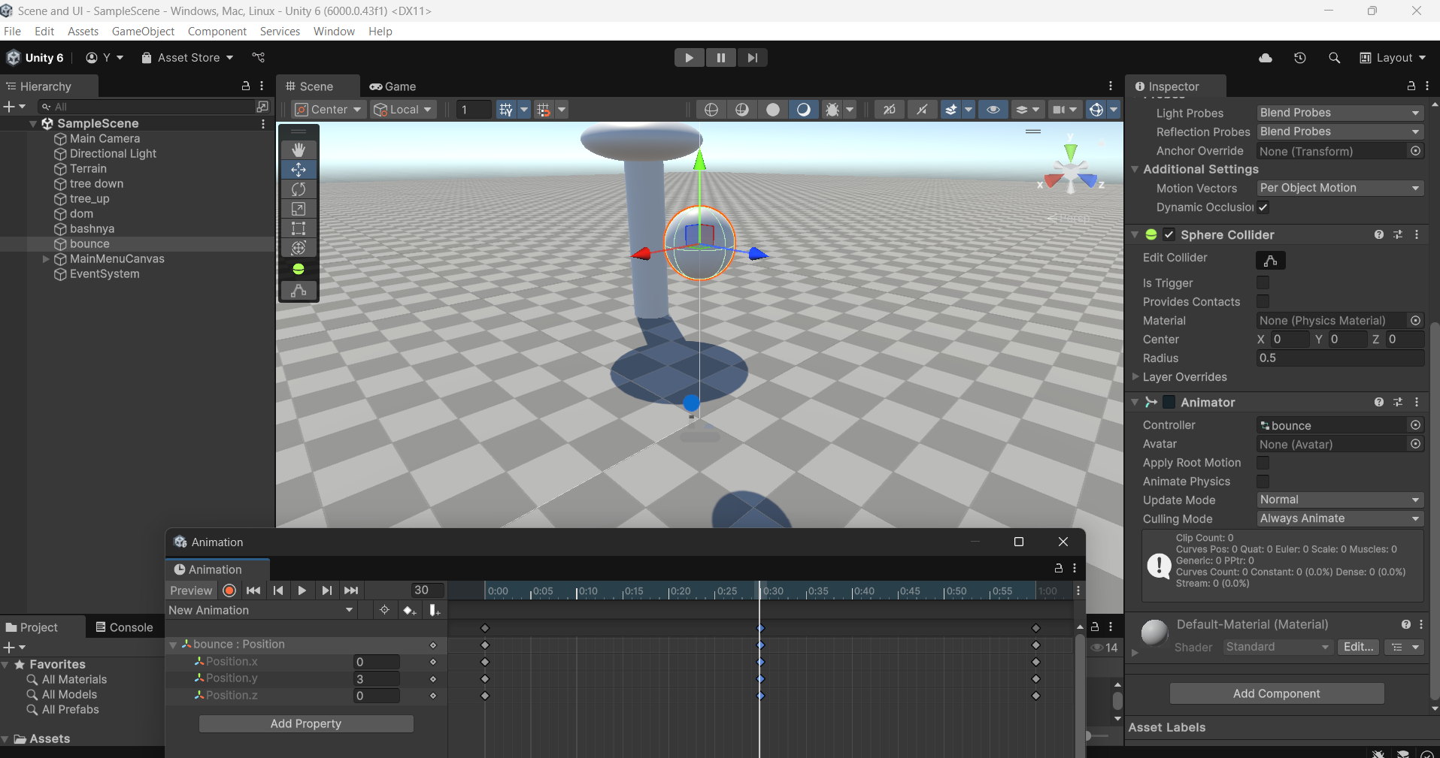

Position 3 (frame 60)

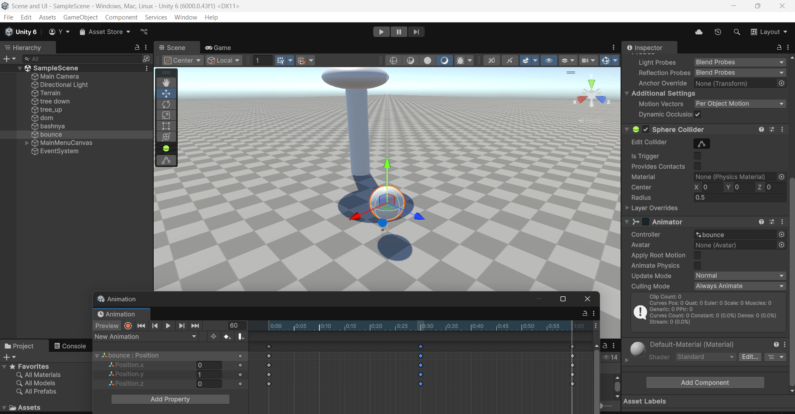

3. UI placement (Canvas and buttons)

I created a Canvas and placed two buttons on it: START and QUIT. I positioned them in the center, adjusted the size and alignment.

4. Scripts and button logic

I created a C# script MenuController.cs, in which I implemented the following methods:

• startGame() — loads the Game Started stage!,

• QuitGame() — ends the application.

I have attached the script to the Canvas. Using OnClick() in the inspector, I linked the buttons to these methods. For the Quit button, I added Debug.Log() to check the method call in the editor.

Script  
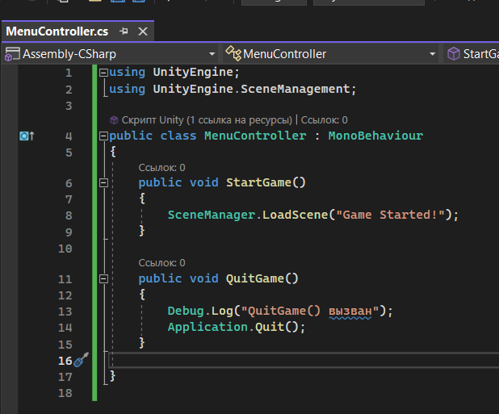

Start

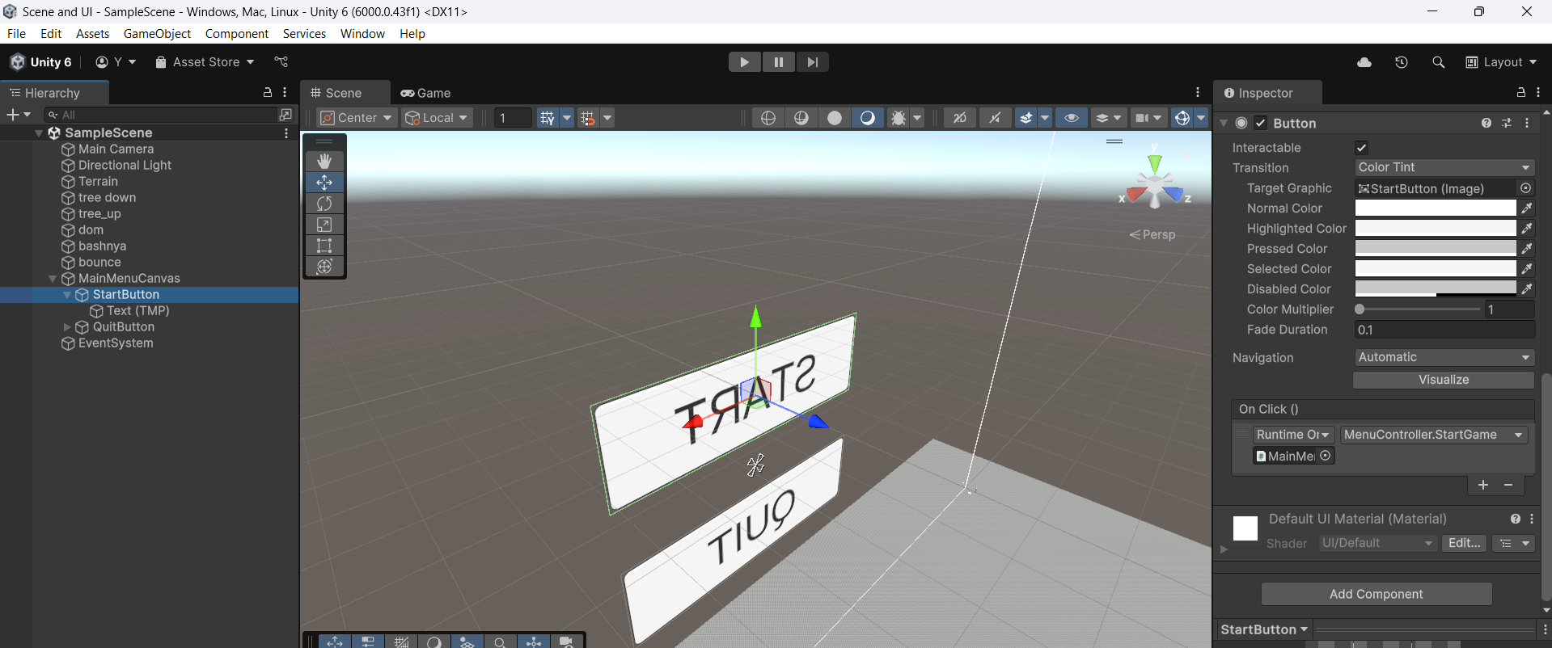

Quit

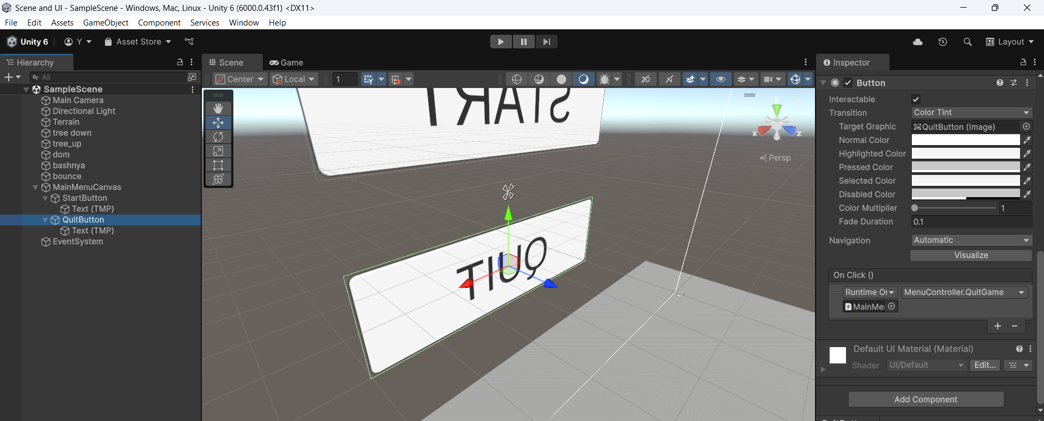

5. Creating the second stage of Game Started!

I created a separate scene where I placed the text Game Started! in the centre. Added both scenes to Build Profiles, set the correct order:

SampleScene — Build Index 0, Game Started! — Index 1.

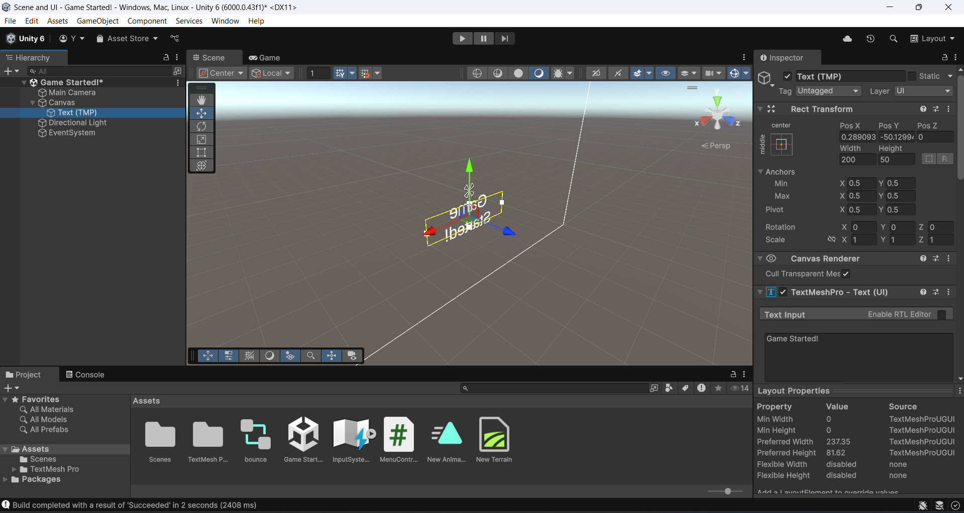

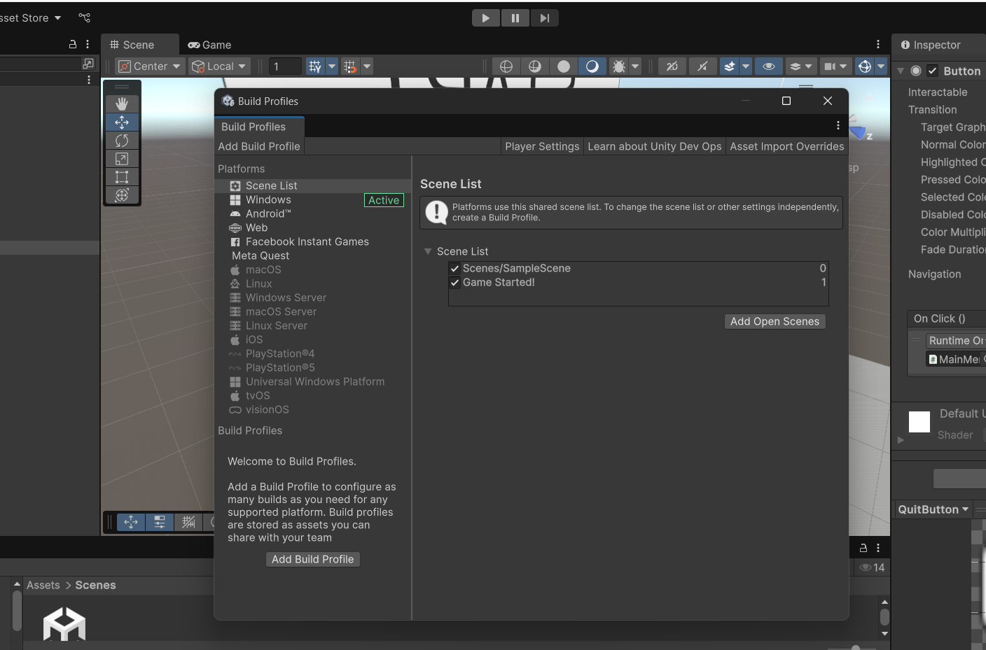

6. Project assembly and test

Bring.exe via File → Build And Run. Checked it out:

• The START button successfully switches the scene,

• The QUIT button ends the game in the assembled version.

